**BUG REPORTING SYSTEM**

I. Problem Definition

Bug Reporting System is an application developed in JAVA programming language. The main aim of the project is to manage the errors or bugs occur during using the product. This application records the reports lodged and their status, so as track the service provided and as to ensure that there will be the timely service.

II. Customer Requirement Specification

- A standalone application that holds the reports and the status of them.

- Order management department, the call center (Front End) people and the Technical support team (back end) should have separate logins.

- Customer has login and register form.

- Details of the warranty that is provided for a particular product.

- The call center (front end) should also be able to lodge and update a report given by the customers and they can check the status of the complaint.

- The back end people should be able to track the details of the report lodged and they can change the status of the report.

II. Project Plan

|  |  |  |  |  |
| --- | --- | --- | --- | --- |
|  | Task | Name | Start Date | Deadline |
| 1 | Login form | Long | 18/11/2019 | 20/11/2019 |
| 2 | Register form | Khanh, Vu | 18/11/2019 | 20/11/2019 |
| 3 | Database connection | Hy | 18/11/2019 | 20/11/2019 |
| 4 | Customer features | Hy, Long | 22/11/2019 | 28/11/2019 |
| 5 | Frontend features | Khanh, Vu | 27/11/2019 | 03/12/2019 |
| 6 | Backend features | Hy | 28/11/2019 | 03/12/2019 |
| 7 | Write document | Hy | 07/12/2019 | 09/12/2019 |

III. Object Oriented diagram

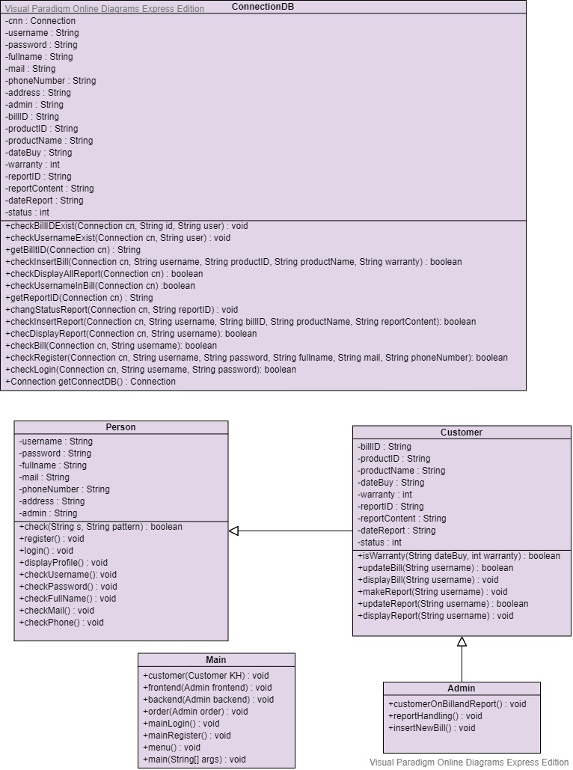

IV. Use-case diagram

